**SMART WATER PUMP**

**A PROJECT REPORT**

***Submitted by***

**GROUP 63**

***In fulfillment for the award of the degree***

***Of***

**BACHELOR OF ENGINEERING**

**In**

**COMPUTER ENGINEERING**



**LDRP INSTITUTE OF TECHNOLOGY AND RESEARCH, GANDHINAGAR**

**Kadi Sarva Vishwavidyalaya, Gandhinagar**

**2020 - 2021**

**LDRP Institute of Technology and Research**

Computer Engineering Department



**CERTIFICATE**

This is to certify that the Project Work entitled **“SMART WATER PUMP”** has been carried out by **GROUP 63** under my guidance in fulfilment of the degree of Bachelor of Engineering in Computer Engineering (6th Semester) of Kadi Sarva Vishwavidyalaya University, Gandhinagar during the academic year 2020-21.

**Ms. Palak Parmar Dr. Shivangi Surati**

Internal Guide, HOD – CE,

LDRP ITR. LDRP ITR.

**ACKNOWLEDGEMENT**

Working in good environment and motivation enhance the quality of the work and we get it from our college through our Software development Project.

We have been permitted to take this golden opportunity under the expert guidance of **Ms. Palak Parmar** from computer department of LDRP-ITR, Gandhinagar.

We are heartly thankful to him to help complete our project successfully. He has given us his full experience and extra knowledge in practical field. We are also thankful to our head of department **Mrs. Shivangi Surati** and all computer staff to guide us.

Finally, we thank all the people who had directly or indirectly help as to complete our project.

**GROUP 63**

**ABSTRACT**

Now-a-days almost every house has overhead tank and most common problem those houses face are water tank overflow these leads to wastage of water. In the era of automation, we decided to work on automating the Water tank using ultrasonic sensors, Arduino board, etc. It’s basic working is that ultrasonic sensors which will detect the water level among two tanks (underground tank and main tank) and will ongoingly notify you the percentage of water being filled through the database and also the application collaboratively upon getting the water tank full or present level.

**LIST OF FIGURES**

|  |  |  |  |
| --- | --- | --- | --- |
| **NO** | **NAME** | | **PAGE NO** |
|  |  | |  |
| 1 | Class Diagram | | 15 |
| 2 | Use case Diagram for System | | 16 |
| 3 | Use case Diagram for User Application | | 16 |
| 4 | TimeLine Chart | | 19 |
| 5 | Data Flow Diagram | | 21 |
| 6 | E-R Diagram | | 13 |
| 7  8 | Activity Diagram for Auto Mode  Activity Diagram for Manual Mode | | 23  23 |
| 9 | Activity Diagram for Feedback | | 23 |
| 10 | Sequence diagram for Offline Mode | | 24 |
| 11 | Sequence diagram for Online Mode | | 24 |
|  |  | |  |
|  | |

**LIST OF TABLES**

|  |  |  |
| --- | --- | --- |
| **NO** | **NAME** | **PAGE NO** |
|  |  |  |
| 1 | Login Table | 20 |
| 2 | Mode Table | 20 |
| 3 | Upper Tank Table | 20 |
| 4 | Lower Tank Table | 21 |
| 5 | Test Case for Login | 25 |
| 6 | Test Case for Dashboard description | 26 |
| 7 | Test Case for Tank Diagram | 26 |
| 8 | Test Case for Tank Diagram | 27 |
| 9 | Test Case for Hardware | 28 |

**TABLE OF CONTENTS**

|  |  |  |
| --- | --- | --- |
| **NO** | **CHAPTER NAME** | **PAGE NO** |
|  | **Acknowledgement** | iii |
|  | **Abstract** | iv |
|  | **List of Figures** | v |
|  | **List of Tables** | vi |
|  | **Table of Contents** | vii |
| 1 | **Introduction**   * 1. Introduction   2. Scope   1.2.1Current Scope  1.2.2 Future Scope   * 1. Project Summary and purpose   1.3.1Project Summary  1.3.2Purpose   * 1. Objectives | 9-11  9  2  2  10  10  10  11  11 |
| 2 | **System Requirement Study**  2.1 User Characteristics  2.2 Software and Hardware Requirements  2.2.1 Software Requirements  2.2.2 Hardware Requirements  2.2.3 Functional Requirements  2.2.4 Non Functional Requirements  2.3 Constraints  2.3.1 Parallel Operations  2.3.2 Safety and security considerations  2.4 Assumption and Dependencies  2.4.1 Assumption | 12-13  12  12  12  12  12  13  13  13  13  13  13 |
| 13 | **System Analysis**  3.1 Study of current system  3.2 Functionality of proposed system  3.3 Feasibility Study  3.3.1 Technical feasibility  3.3.2 Operational feasibility  3.3.3 Economic feasibility  3.4 Requirement Validation  3.5 Class Diagram  3.6 Use Case Diagrams  3.6.1 Use Case Diagram of system  3.6.2 Use Case Scenarios and Diagram of User Application | 14-17  14  14  14  14  14  15  15  15  16  16  16 |
| 4 | **Project Planning - Estimation and scheduling**  4.1 Estimation  4.1.1COCOMO based Effort  4.2 Time Line Chart | 18-19  18  18  19 |
| 5 | **System Design**  5.1 Database Dictionary  5.2 Data Flow Diagram  5.3 Entity Relationship Diagram  5.4 Activity Diagram  5.4.1 Activity diagram of Auto Mode  5.4.2 Activity diagram of Manual Mode  5.4.3 Activity diagram of Feedback  5.5 Sequence Diagram | 20-24  20  21  22  23  23  23  23  24 |
| 6 | **Testing**  6.1 Test Cases | 25-28  25 |
| 7 | **Experience, Limitations And Future Enhancement**  7.1 Experience during project development  7.2 Limitations  7.2 Future Enhancement | 29  29  29  29 |
| 8 | **Bibliography**  8.1 Conclusion  8.2 Bibliography | 30  30  30 |

|  |
| --- |
|  |

**Introduction**

* 1. Introduction
  2. Scope
  3. Project Summary and purpose
  4. Objectives

**1.1 Introduction**

Nowadays, it is difficult to manage each and every single thing in a big house. Technology has developed so rapidly that we now expect to have automation everywhere so as to ease our work and lifestyle. Rather than remembering every details of house and doing it ourself we prefer automation as it allows us to prioritize different other things.

These smart water pump not only adds value to the House but also in Industries. We have observed that Water wastage is also common in industries. The water level indicator sensors are used in factories, chemical plants, and electrical substations and in other liquid storage systems. There are many possible uses for this simple system, examples include monitoring a sump pit (to control pump activation), rainfall detection, and leakage detection. Electronic water level sensors have the capability of alerting if there is a water leak somewhere in the factory. When the water level is too high or too low or exceeds the higher limit, it can detect the water level easily by application which is linked to that particular device. We can also measure the fuel level in motor vehicles and the liquid level containers which are huge in the companies.

We don’t know a single person who would say that they didn’t enjoy automating their work. It is always very special about knowing that our half work is done by technology and then finally we can work on our passion or whatever we are interested in.

**1.2 Scope**

**1.2.1 Current Scope**

The scope of our application is to provide easy lifestyle and avoid wasting water. These application and set-up will make it handy for people to track their working of water tank and to save water. Above all it will be secured and user will be able to track their daily usage.

**1.2.2 Future Scope**

In near future due to too much usage of water there is probability that people will need to pay to use water like the way we pay bills for electricity. So as to save water and money, these application and setup can be used as it tracks the usage avoid wasting of water.

* 1. **Project Summary and purpose**

**1.3.1 Project Summary**

In this application, we will have Login page from where the user logs in. Further the user will have 2 options to activate the water motor either by auto mode or manual mode. And in the home screen the user will be able to see the percentage of the tank filled both underground and Main. Water capacity will also be visible to the user.

Components we used:

* ESP8266 [ NodeMCU ]
* Ultrasonic Sensor [ HC – SR04 ]
* IR Sensor Module
* Submersible Mini Water Pump [ 3-6 V DC ]
* Jumper Wire

Setup

* Two Tanks with Ultrasonic sensors on top
* Main tank will also have IR sensor
* Two tanks are connected with Submersible Mini Water Pump
* All the electrical components are connected to ESP8266
* A home Wi-Fi is also required

**1.3.2 Purpose**

Aim of the smart water pump is to avoid wastage of water and automate the system.

* 1. **Objectives**

If these applications and set up needs to become successful to make people realization of saving water in every aspect and maintaining their tanks so as to avoid and future consequences.

**System Requirement Study**

2.1 User Characteristics

2.2 Software and Hardware Requirements

2.3 Constraints

2.4 Assumption

* 1. **User Characteristics**
* Software allows user to manually turn the motor on or of and keep other option as auto.
* User should be able to understand to operate the application.

**2.2 Software and Hardware Requirements**

**2.2.1 Software Requirements**

* Server:

Database: Firebase(NoSQL)

* Client:

Web Browser: Any browser

**2.2.2 Hardware Requirements**

* Server:

Harddisk:50Gb or higher

* Client:

Any PDA(Personal Digital Assistant)

**2.2.3 Functional Requirements**

* User must be able to login
* User must be able to edit their own profile
* User must be able to switch from auto to manual and vice versa
* User must understand how to operate application

**2.2.4 Non-Functional Requirements**

* User friendly application
* Easy to tackle and track the process
* Able to understand easily
* Flexible service-based on real time water level indicator which will be highly desirable for providing the tank status.
* System will be consistent and it will be able to tackle heavy workload.

**2.3 Constraints**

**2.3.1 Parallel Operations**

The production web server system will be able to handle multiple connections from the clients. Clients will use their personal computers, desktop or laptop, that has a capability of running web browser with required plug-ins to interact with our product through the NodeMCU (based on ESP8266 WIFI module). The administrators will have the high-end technology solutions and machines to support their administrative operations enabled by the product.

**2.3.2     Safety and security considerations**

The smart water pump will require a means of providing water level update through ESP2866 WIFI module. In order to ensure the utmost security of these There is the security key which is connected to the hardware and software which will be matched on the time of installation. And in case of any issue midway the customer will have to contact service provider.

**2.4     Assumption and Dependencies**

**2.4.1 Assumption**

* We will be able to track water level in the real time and keep the customer updated through the app.
* System should be available when user needed.

**System Analysis**

3.1 Study of current system

3.2 Functionality of proposed system

3.3 Feasibility Study

3.4 Requirement Validation

3.5 Class Diagram

3.6 Use Case Diagrams

**3.1 Study of current system**

Smart Water Pump is a integrated system which will pay attention to both of your water tanks i.e. Underground and Main tank. It will provide you manual and automatic motor system. Motor will be smartly operated according to your tanks level or manual instructions.

**3.2 Functionality of proposed system**

* Selection of Modes either auto or manual.
* System uses ultrasonic to measure the percentage of tank filled which will be notified to user.
* Automating the water pumps.
* Customer feedback
* 24 x 7 Digital support

**3.3 Feasibility Study**

**3.3.1 Technical Feasibility**

Technically feasible because we can implement problem solutions & also less chances of human mistakes. Accuracy will be available in the percentage of tank filled. And in case the mode is set as manual, then also it will notify the percentage of tank filled so as to avoid overflowing of water.

**3.3.2 Operational Feasibility**

It is operationally feasible because the installer will have to install system once and user will have no worry to look after except time-to-time services which will be notified through application.

**3.3.3 Economic Feasibility**

It is feasible economically because a client who want to stop the overflow of tank will be definitely able to use this 1-time instalment product and then keeps on servicing on regular basis which will help system to last longer.

**3.4    Requirement Validation**

Validation must be required because all the data are entered are properly or not. In our web application email must be check. Eg: must follow [abc@abc.com](mailto:abc@abc.com). Most important real time lo must be shared in order to place order offline.

**3.5 Class Diagram**

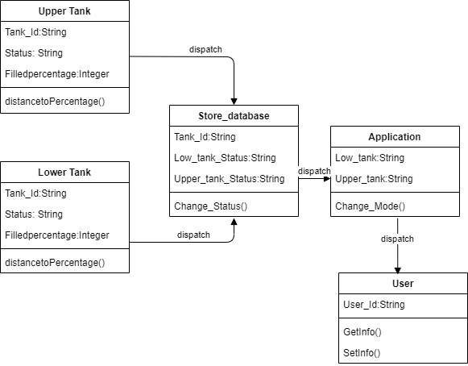

**3.6 Use Case Diagrams**

**3.6.1 Use Case Diagram of system**

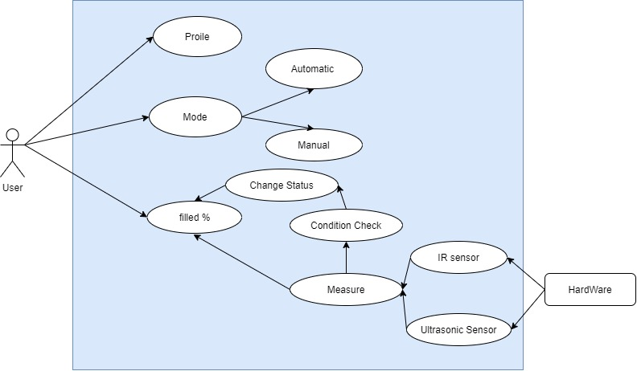

**3.6.1 Use Case Scenarios and Diagram of User Application**

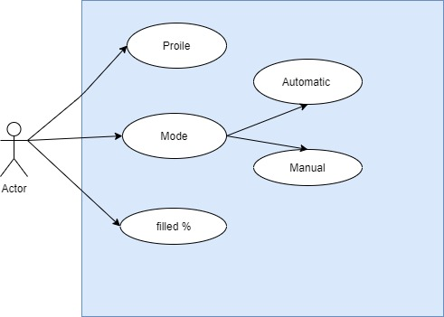

**Scenario for User Application:**

1. Introduction : This use case describes how an User manages the application.
2. Actor : User
3. Precondition : Must have created User Profile
4. Postcondition: None
5. Basic Flow: This Use Case starts when the user wishes to check the water level

* User creates the profile through which user can check the status to water tanks.
* User can prefer either automatic or manual mode as per the convenience.

**Project Planning - Estimation and scheduling**

**4.1 Estimation**

**4.1.1 COCOMO based Effort**

A software project is all about managing and planning of project and it’s time management. To start project estimated time is required so as to plan perfectly. Some important project parameters are project size, duration, cost and efforts. By using COCOMO model we can find the estimation.

In COCOMO model there is three class

1.Organic

2.Semidetach

3.Embedded

In our project is under a Semidetached system as experience is at initial level and team is small and each works in different domain.

Consider our project using semidetached system mode with 20,000 line of code. We will obtain estimation for this project as follows:

Effort Estimation:

E=a*(KLOC)^b person-month

= (3.0) *(20) ^1.12 person-month

= 85.95 person-month

Duration:

D=e*(effort)^d month

**=** 2.5(85.95) ^0.35 month

= 11 month

**4.2 Time Line Chart**

**System Design**

* 1. **Database Dictionary**

5.1.1 Login Table

|  |  |  |  |  |  |
| --- | --- | --- | --- | --- | --- |
| **Column_Name** | **Datatype** | **Length** | **Primary Key** | **Nullable** | **Description** |
| login_username | varchar | 12 | yes | - | primary Key of login table |
| password | varchar | 15 | - | - | password |

* + 1. Mode Table

|  |  |  |  |  |  |
| --- | --- | --- | --- | --- | --- |
| **Column_Name** | **Datatype** | **Length** | **Primary Key** | **Nullable** | **Description** |
| Automate | varchar | 10 | yes | - | default |
| Manual | varchar | 20 | - | - | Customer control |

* + 1. Upper Tank Table

|  |  |  |  |  |  |
| --- | --- | --- | --- | --- | --- |
| **Column_Name** | **Datatype** | **Length** | **Primary Key** | **Nullable** | **Description** |
| Tank_ID | varchar | 10 | yes | - | Primary key |
| Tank (Upper) | varchar | 20 | - | - | Tank number |
| Status | varchar | 50 | - | - | Low/High |
| Percentage filled | Integer | 25 | - | - | Percentage |

* + 1. Upper Tank Table

|  |  |  |  |  |  |
| --- | --- | --- | --- | --- | --- |
| **Column_Name** | **Datatype** | **Length** | **Primary Key** | **Nullable** | **Description** |
| Tank_ID | varchar | 10 | yes | - | Primary key |
| Tank (Upper) | varchar | 20 | - | - | Tank number |
| Status | varchar | 50 | - | - | Low/High |
| Percentage filled | Integer | 25 | - | - | Percentage |

* 1. **Data Flow Diagram**

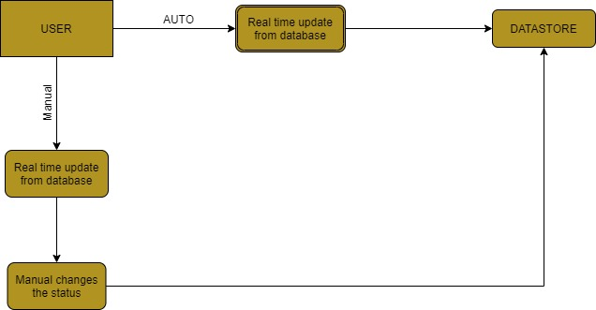

* 1. **Entity Relationship Diagram**

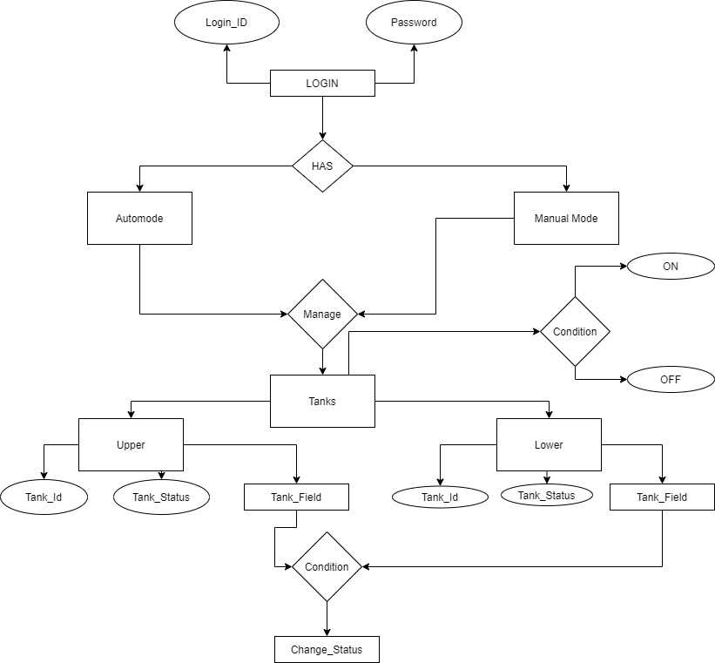

**5.4 Activity Diagram**

5.4.1 Activity diagram of Auto mode

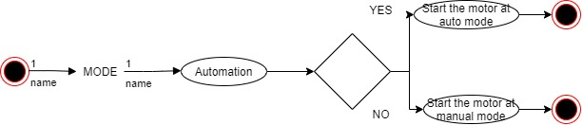

5.4.2 Activity diagram of Manual mode

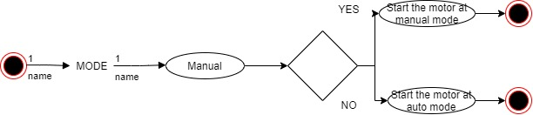

5.4.3 Activity diagram of feedback

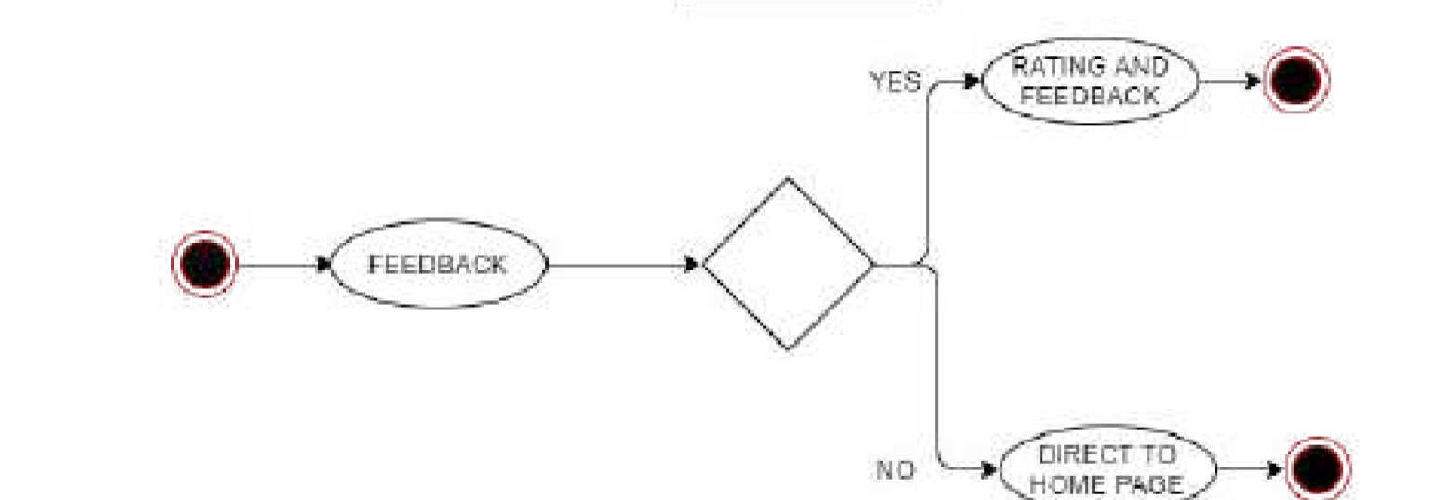

* 1. **Sequence Diagram**

SEQUENCE DAIGRAM FOR AUTO MODE

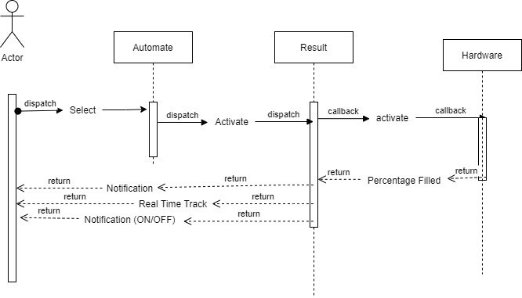

SEQUENCE DAIGRAM FOR MANUAL MODE

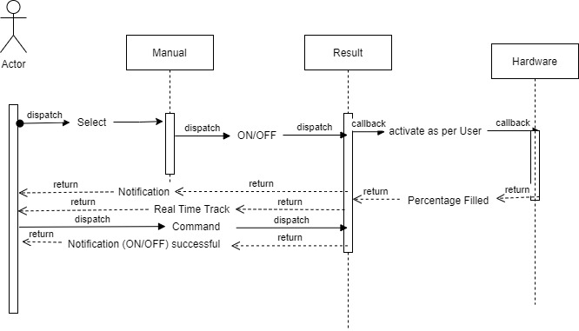

**Testing**

**6.1 Test Cases**

* **TEST Case-1**

Test Case for Verify Login Page

Test Case Id: test_id1

Test Priority (Low/ Medium/ High): High

Test Title: Verify Login Page

Description: Test The Login Page

Pre-conditions: User has valid Username And Password

|  |  |  |  |  |  |
| --- | --- | --- | --- | --- | --- |
| Step | Test Steps | Test Data | Expected Result | Actual Result | Status: PASS / FAIL |
| 1 | Navigate to the Login Page | ID/Password | User should be able to Login. | User is Navigated to Main Page with  successful Login. | PASS |
| 2 | Provide Valid Username | User ID = [abc@gmail.com](mailto:abc@gmail.com) | User ID Should Be  Valid. | User ID Is Valid. | PASS |
| 3 | Provide Valid Password | Password = xyz@123 | Password Should Be Correct. | Password Accepted. | PASS |
| 4 | Click on Login Button | - | - | - | PASS |

* **TEST Case-2**

Test Case for Description on dashboard

Test Case Id: test_id2

Test Priority (Low/ Medium/ High): High

Test Title : Description on dashboard

Description: Verifying user as either customer

Pre-conditions: User has valid Username And Password

|  |  |  |  |  |  |
| --- | --- | --- | --- | --- | --- |
| Step | Test Steps | Test Data | Expected Result | Actual Result | Status: PASS / FAIL |
| 1 | Buttons properly visible(Manual) | - | - | - | PASS |
| 2 | Buttons properly visible(Automatic) | - | - | - | PASS |

* **TEST Case-3**

Test Case for Tanks diagram

Test Case Id: test_id3

Test Priority (Low/ Medium/ High): High

Test Title : Percentage of tank filled

Description: Percentage of tank filled

Pre-conditions: WIFI must be on

|  |  |  |  |  |  |
| --- | --- | --- | --- | --- | --- |
| Step | Test Steps | Test Data | Expected Result | Actual Result | Status: PASS / FAIL |
| 1 | Lower tank | Figure | Figure | Figure with percentage of water filled | PASS |
| 2 | Lower tank status | LOW  /HIGH | As per the real time data | As per the real time data | PASS |

* **TEST Case-4**

Test Case for Tanks diagram

Test Case Id: test_id3

Test Priority (Low/ Medium/ High): High

Test Title : Percentage of tank filled

Description: Percentage of tank filled

Pre-conditions: WIFI must be on

|  |  |  |  |  |  |
| --- | --- | --- | --- | --- | --- |
| Step | Test Steps | Test Data | Expected Result | Actual Result | Status: PASS / FAIL |
| 1 | Upper tank | Figure | Figure | Figure with percentage of water filled | PASS |
| 2 | Upper tank status | LOW  /HIGH | As per the real time data | As per the real time data | PASS |

* **TEST Case-5**

Test Case for Hardware

Test Case Id: test-id5

Test Priority (Low/ Medium/ High): High

Test Title: Online Mode

Description: Working of hardware

|  |  |  |  |  |  |
| --- | --- | --- | --- | --- | --- |
| Step | Test Steps | Test Data | Expected Result | Actual Result | Status: PASS / FAIL |
| 1 | ESP8266(NodeMCU) | - | Connects the application with all the hardware | Connects the application with all the hardware | PASS |
| 2 | Ultrasonic Sensor | - | Judge the distance b/w it and the water and return it the water filled in it | Judge the distance b/w it and the water and return it the water filled in it | PASS |
| 3 | IR Sensor | - | Sense the object around it | Sense the object around it | PASS |
| 4 | Mini Water Pump | - | Supply 120 liters per hour | Supply 120 liters per hour | PASS |

**Experience, Limitations and Future Enhancement**

7.1 Experience during project development

7.2 Limitations

7.2 Future Enhancement

**7.1 Experience during project development**

Learnt so many technichal as well as non-technical things. In technical we learnt so many designing application searches and learn and after designing the software or diagram. We also learnt creating own API connecting it to over hardware and software. In non-technical things we learnt how to communicate to our teammates and how to collaborate with them.

**7.2 Limitations**

One of the all-time limitations in this application is that this application requires active internet connection.

The Modules and hardware and software used in the project should be connected 24/7. Any problem in either of 3 will ruin the notification system and customer might not be able to get update.

**7.2 Future Enhancement**

In current application the user can only see the percentage of water filled in tank and can change the setting from auto to manual and vice versa. So as to advance the feature we thing of adding daily consumption and usage percentage so as to give the rough idea to the user. Statistical usage over a day, month, year will be the next update. So as to save water we may add the feature of filling the tank as per the usage of the user.

**Bibliography**

**8.1 Conclusion**

The proposed system would be a stepping stone in saving water effectively with automation. It will decrease the rate of wastage of water and indirectly a step to save over mother Earth. It will potentially increase the affection towards the Earth.

**8.2 Bibliography**

Wikipedia

Quora

<https://arduinojson.org/>

<https://www.youtube.com/playlist?list=PLJetLDY7yKupm5WTx02ylh1I25rJLPvXe>

<https://www.youtube.com/watch?v=LIiFVYXuwTU>

<https://roboindia.com/tutorials/serial-monitor-nodemcu/>